NON-PIGGABLE PIPELINES INTEGRITY MANAGEMENT
Igor S. Kolesnikov, Deputy Director General on R&D, expert of SEIS (System of Examination of Industrial Safety) of the 2nd level; Yakov V. Vorobyev, , Senior Researcher, Ph.D., expert of SEIS of the 1st level; Valerian P. Goroshevskiy, Technical Director, Ph.D., expert of SEIS of the 2nd level; Svetlana S. Kamaeva, Director General, Ph.D., expert of SEIS (System of Examination of Industrial Safety) of the 2nd level.
LLC RDC “TRANSKOR-K”

SUMMARY: The article briefly describes the main provisions of technical diagnostics of pipelines using magnetic tomography method (MTM). MTM provides remote registration of complex mechanical stresses and calculation of serviceability parameters (Psafe, Tsafe, ERF) in areas with metal defects that ensure reliability. MTM AQUA and MTM (for subsea pipelines) are applicable including facilities not subject to the in-line inspection (ILI): field pipelines, pipelines of GCS, pumping stations and chemical (petrochemical) production; branch pipelines; bypass connections, etc. MTM data provide the basis for conclusions of Industrial Safety Expertize on hazardous production facilities by the real state of the metal under acting operational loads.
KEY WORDS : Magnetic tomography method; Non- piggable and difficult pipeline; performance based integrity management program; ECDA\ICDA program.
Pipeline transport is leading in terms of cargo traffic, 100 times exceeding other types of transport. How reliable is the pipeline infrastructure in Russia? The piping network is worn out in its great extent and it needs renovation. Remedial measures under the reliability program should be planned basing real state of metal, but in practice the measures are limited to the examination of indirect characteristics of insulation coating and effectiveness of active anticorrosion protection (CP). Survey of metal all over the length of objects until recently was only possible with the use of in-line diagnostics (ILI).
More than 1 million km of Russian pipelines are not subject to the iLI, and only slightly more than 20% - mainly gas and oil pipeline permit to conduct a survey of the metal (Fig. 1). Thus, for the vast majority of objects including commercial, distribution, technological, municipal pipelines the application of ILI is impossible or unreasonable. The metal of such pipelines (in foreign terminology «Non-piggable & Difficult») is controlled selectively, and the volume of the control (the portion of the total length of the object) is usually not more than 2%, due to the high cost of excavation for providing access to the surface of the metal, and as a consequence, extensive labor expenditures of the programs for direct control of internal and external corrosion (ECDA \ ICDA program).
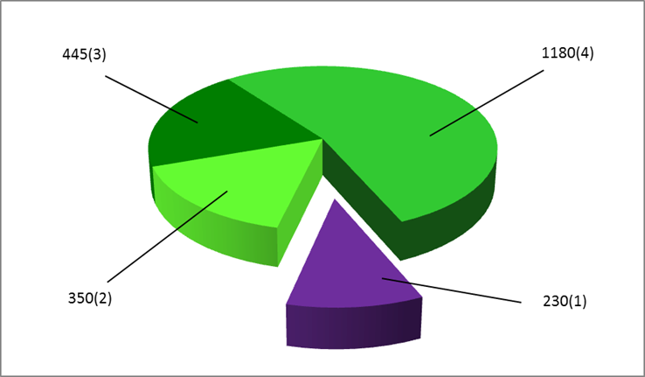
Fig. 1 NDT Control of pipeline metal in Russia, in th. Km: 1) ILI - gas and oil main pipeline; non-piggable pipelines 2) Oil and gas facilities and technological piping of GCS; 3) Gas pipeline distribution branches and gas supply pipelines; 4) Housing pipelines with diameters greater than 200 mm (Ø> 8”)
In fact, the diagnostic service in this segment of the pipeline industry is in dire need of innovative technological solutions for metal control, which will justify the size and timing of the reconstruction of infrastructure, since the delay threatens to increase in the number of anthropogenic disasters, and losses due to the increasing failure rate.
Moreover, this market is growing rapidly. The data published by Phil Hopkins (International Institute of Petroleum Technology) says that the pipeline infrastructure of the world has increased by its length of nearly 100 times over about 50 years. It is estimated that the increase of the total length of the world's networks can be up to 7% per year over the next 15 years. It is expected that 32,000 kilometers of new pipelines will be built in the world. The total length of main pipelines of high pressure around the world will increase by estimated 3.5 million miles. Of these, 64% will be systems for transporting natural gas, 19% - for transferring petroleum products, and 17% - for transportation of crude oil. Moreover, the share of offshore pipelines in the North-Western Europe, Asia-Pacific region and the Gulf of Mexico will increase by 8000 km per year.
As numerous accidents of “non-pigabble & difficult” pipelines demonstrate, their control and safety is a very important problem for the whole world. In the last decade, the innovative technical proposals for the metal inspection of the whole length of the mentioned objects became the magnetic methods, primarily due to the Russian developments. In addition, the technology of the long-wave ultrasonic testing has been successfully tested and introduced.
This publication provides a brief description of the magnetic tomography method (MTM) that has confirmed its competitiveness in the world market: for 12 years since the agreement of the Russian standard RD 102-008-2002 (AO VNIIST) by using the apparatus and method of MTM patented in Russia, USA, Canada and Europe, more than 17 000 km in 25 countries have been examined. Physical basis of MTM is based on a fundamental discovery of inverse magnetostriction - Villari effect linking mechanical stresses and magnetic properties of ferromagnetic objects [S. V. Vonsovskiy. Magnetism, M., Ed. Science, 1971, 1032 p.]. Graphically the principle of mechanical stresses recording by the measured characteristics of the magnetic field of the extended ferromagnetic structure is shown in Fig. 2; the process of MTM field scan is shown in the photo (Fig. 3).
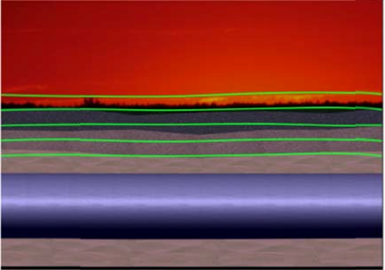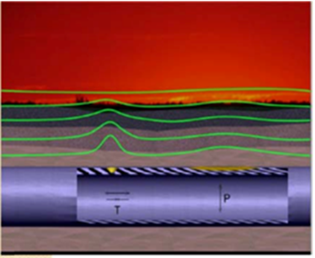

Fig. 2: Villari-effect: distribution of magnetic field of piping made of a ferromagnetic material (steel, cast iron) in the absence of stress concentrators (a) and in the presence of stress concentrators in areas of metal defects ((b)
The fundamental guarantees of MTM are the declared quality indicators - the probability of detecting stress anomalies conjugating with defects of all types of metal and with increased loadings as well, caused by sags, flexures, areas of general or local loss of stability of the pipeline on soils with low bearing capacity, landslips or seismic phenomena (POD), moreover, the probability of the correct interpretation of the degree of danger of anomalies (POI) by the value of characteristic parameter - F.
The main limitation of this method is the distance from the MTM equipment to the axis of the remote (underground or underwater) object, which should not exceed 15 diameters of the pipe. The methodology of registration of SDS (stress-deformed state) and calculation of stress concentration degree, as well as guarantees and limitations of the method is discussed in details in publications [RD 102-008-2002, Instruction for diagnosing the technical condition by the non-contact magnetometer method, Ed. AO VNIIST, 2002. Comp. Gosgortechnadzor RF Letter № 10-03 / 1181 of 10.12. 2002, 49 p.; V.P. Goroshevskiy, S.S. Kamaeva, I.S. Kolesnikov. “SEEING” THROUGH THE EARTH”. SCIENCE in Russia, Ed. Presidium of the Academy of Sciences RF, 2003, № 6 November-December (138), p. 13-15].
The dependence between the registration step and recording of magnetic field parameters during the scanning process and the diameter and depth of the pipeline was experimentally proved. The assessment of danger degree of MTM anomalies is performed by integral index F, taking into account the length of magnetic anomaly S, m; as well as the amplitude and shape of distribution of the magnetic field vector. Integral index F reflects the amount of excess of the magnetic field recorded values ​​ above the background values​​; the density of peak values and character of their distribution; and is calculated by formula (1).
F=(A+1)e-K/S, (1)
where: А - the number of lines of stress concentration in the area of ​​magnetic anomaly;
S – length of anomaly, m; determined by the number of measurement points of the magnetic field parameters (the number of scanning steps), K - degree of stress concentration in zone of stress concentration, which is calculated by formula (2) :
K=Σ√(cos2α+cos2β+cos2γ), (2)
where сos α, cos β, cosγ –direction cosines of the stress concentration vector;
 - coefficient taking into account the period of accident-free operation, calculated by formula (3) :
=ln(Pраб./Po)/(Tо-Tз), (3)
where Pраб – operating pressure in the pipeline at the time of inspection;
Po – design pressure;
Tо – date of inspection;
Tз – date of commission;
MTM has high sensitivity - not less than 80% anomalies caused by metal defects of any type are detected within the range of mechanical stresses from 30 to 85% SMYS. The following defects are revealed: defects of base metal (metal loss due to external or internal corrosion, erosion, crack-like defects in any orientation, including SCC, mechanical defects and changes in pipe geometry), as well as defects of weld joints of any nature and areas under increased loadings - in seismically active zones in the permafrost, with landslips, etc. In this case, the selectivity of the method as a whole is weak, and only predictions on the nature of defects can be made, but this does not diminish the prospects for the MTM application as a tool for the registration of real stress. The ranking of pipeline sections with defects by categories of technical condition allows us to justify their entry into repair or reconstruction by replacing.

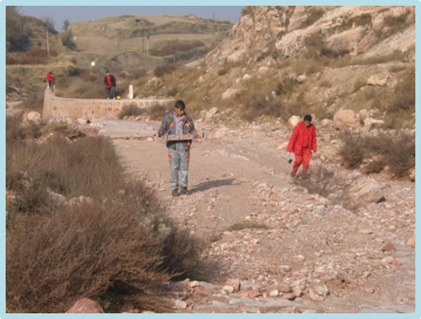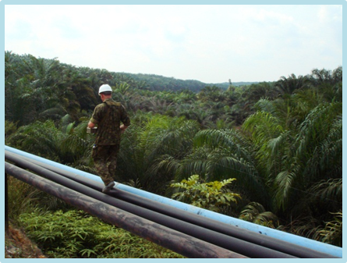
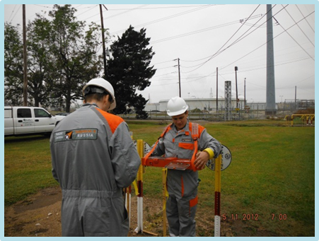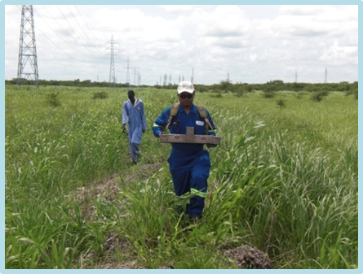
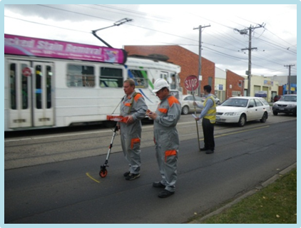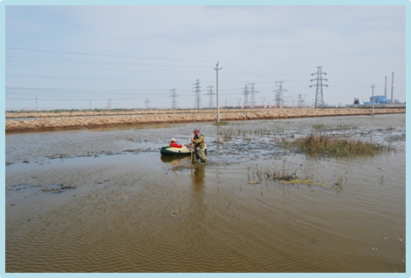
Fig. 3: Field MTM inspection of underground pipelines: China, Indonesia, the United States, Sudan, Australia, Saudi Arabia
Common risk assessment of operation of objects with metal defects is based on calculations of strength, fracture strength, fracture mechanics, etc. calculation of local stresses in the defective areas by geometrical dimensions of the defects. Since MTM allows you to record directly the mechanical stresses in operating conditions, which is important, for example, for subsea pipelines, the conditions of weak bearing capacity of soils (permafrost), increased seismic activity, where pipeline damage can take place because of stability loss, the reliability management program can be built on the basis of MTM data without the need for calculations of geometric dimensions of individual defects.
Since 2012, after winning the competition of “Arctic Technology” (Houston, USA) innovative technologies, we’ve launched the successful application of the joint Russian-Malaysian development with the national company PETRONAS - modification of AQUA MTM®. More than 300 km of offshore objects have been already examined In Malaysia, Indonesia and the United Arab Emirates (Fig. 4).
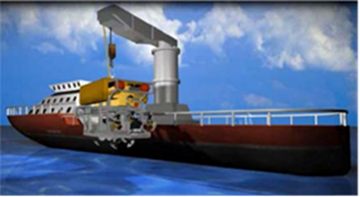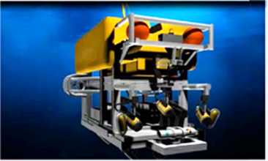
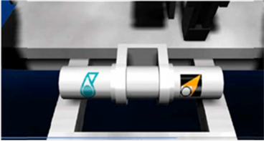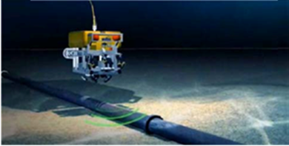
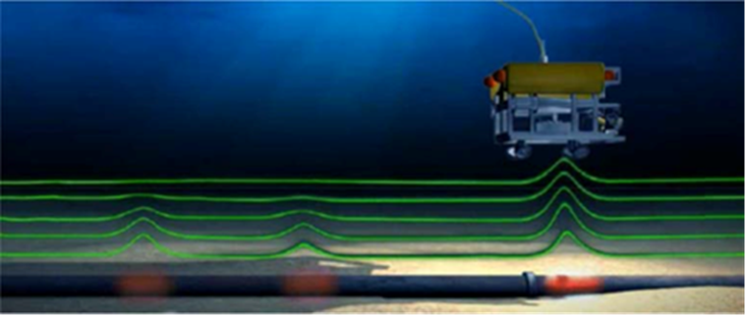
Fig. 4: Deploying AQUA MTM® inspection involving a vessel, subsea remotely operated vehicle (ROV) and a complex with an AQUA SKIF magnetometer
AQUA MTM® technology will be in demand in future to improve the reliability of such export mains as the Russian subsea “Streams”, as well as numerous pipelines of offshore oil and gas production, the length of which is rapidly increasing.
The concept of risk management according to MTM (AQUA MTM) is reflected in the diagram (Fig. 5). According to the traditional approach the pipeline parameters (safe operating pressure Psafe, safe operation term Tsafe, safe pressure factor or ERF) are calculated based on the value of local mechanical stresses Si and stress concentration factor SCF. By the ILI data based on indirect measurements of geometrical parameters of defects, parameter Si is calculated for each type of defect in accordance with generally accepted methods: SNIP 2.06-0.5-85: ASME BG 31, API, DNV, FEM.
According to MTM data, factor SCF is calculated on the basis of results of indirect recording of Si value - local complex mechanical stresses (including longitudinal, circumferential, shear and residual) for each section of the pipeline.

Fig. 5: Calculation of pipeline safety parameters according to the data of defects geometric dimensions after the in-line inspection (ILI) and by the results of the MTM
In order to establish the degree of correlation of MTM with calculations according to the accepted methods the comparison of outcome indicators (serviceability parameters) in the anomalous zones with different types of defects was carried out. Such large-scale projects have been implemented in the special test fields of R&DC “Transkor-K” \ VNIIST and PETRONAS (Malaysia). For detailed ascertainment of the reasons for occurrence of MTM anomalies a series of experiments was carried out on the registration of stress during step loading of a welded pipeline of 40-109 m with artificial metal defects (Fig. 6, 7).
In addition to the identification of MTM anomalies the strain measurement was carried out in areas with defects, metallographic examination and numerical analysis by the finite element method. The maximum stresses of the applied stresses in the area of some anomalies exceeded the yield stress of pipe material, which is reflected in the charts of stress values ​​according to MTM data (Fig. 7, curves 2-4 and 2-7). In these areas the strain gauges also demonstrated the transition to plastic deformation during the internal pressure increase.

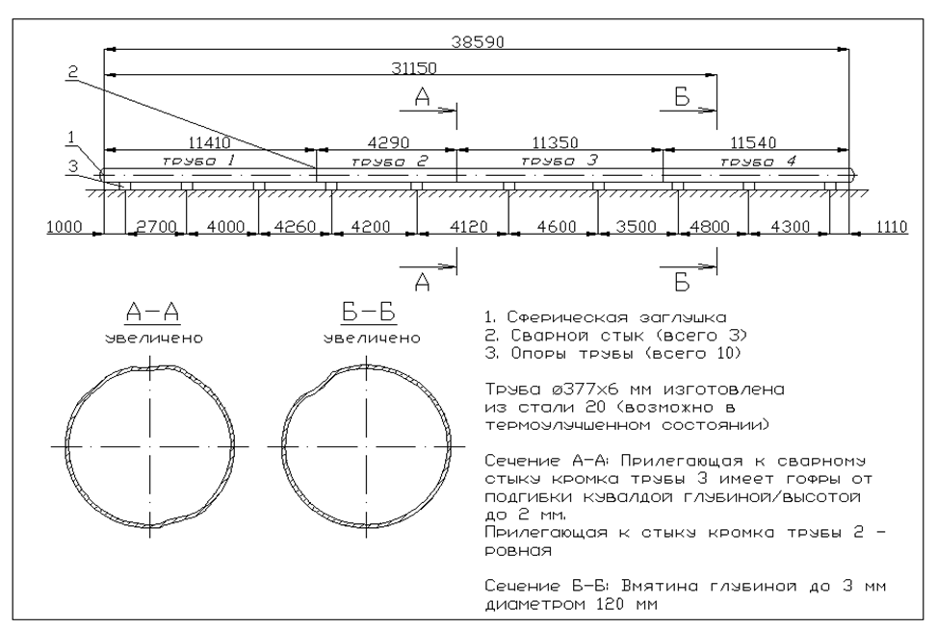
Fig. 6: Sketch of the experimental facility - a full-scale test bench for full-scale tests
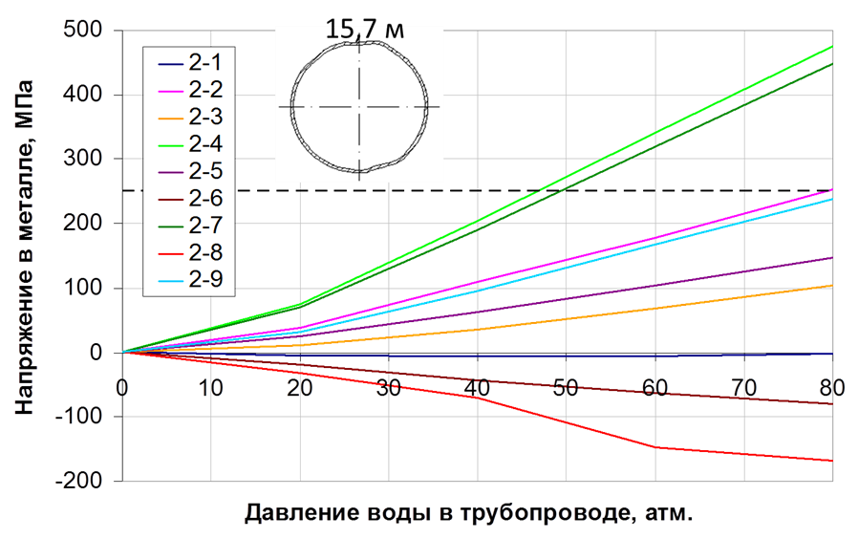

Fig. 7: Proceedings of the experiment on stress registration in the area of MTM anomaly conjugated with “dent” metal defect

The computer modeling of the pipeline stress state by numerical methods (finite element method), made in the Mechanics Laboratory of St. Petersburg State Polytechnical University, RF, fully confirmed the data of strain measurement and data of MTM. Figure 8 shows the range of magnetic anomalies, where gray color corresponds to the maximum stress concentration and to areas of plastic deformation.

For completeness of the experimental data the metallographic examination of samples taken from the anomaly areas of operating pipelines was carried out. Some deviations in the microstructure were recorded, usually not detected by the traditional non-destructive testing (Fig. 8). Not only the plastic deformation was revealed, but internal micro-cracks originated as a result (Fig. 5) Surface micro-cracks in radiographic interpretation represent the result of a combination of high stresses (416 MPa) and high density of dislocations (2,3x109sm -2).

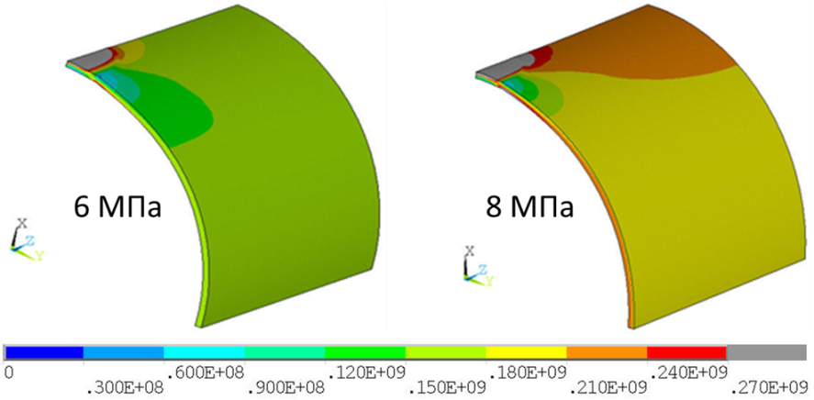

Fig. 8: Results of numerical modeling (FEM) of mechanical stresses in the areas of MTM anomalies

The data on the interdependence of magnetic quantities with mechanical stresses in test field conditions is shown in Fig. 9. Rather high correlation between changes in magnetic flux density with increasing hoop stresses in the pipe metal is confirmed – the equations of linear approximations and root-mean-square deviation are shown.

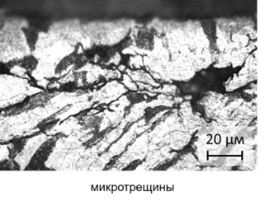
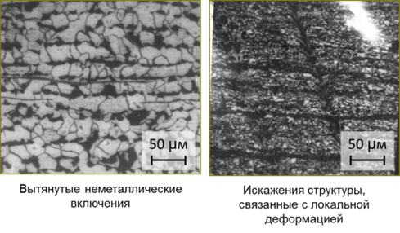
Fig. 9: Results of metallographic examination of thin sections from the areas of MTM anomalies: plastic deformation, micro-cracks

The metallographic studies and X-ray structural analysis confirmed the identified patterns of changes in the structure of local areas of stress concentration in areas of MTM anomalies both in the test field conditions, and for metal selected from the operating pipeline.

According to the results of experiments at the test field of PETRONAS, the Malaysian Oil Company, some Additions to the Standard documentation on safety rules of pipeline transportation of the American Society of Mechanical Engineers were developed and submitted to the ASME [S. Kamaeva, V. Goroshevskiy, I. Kolesnikov. ASME-MTM (AQUA MTM) Correlation: Burst Strength Prediction Using MTM Inspection Data, Conference Proceedings “Mechanical Design Technical Committee” B31 Code Week, Sep. 17-21, 2012, Norfolk, Virginia, USA, p. 1176].
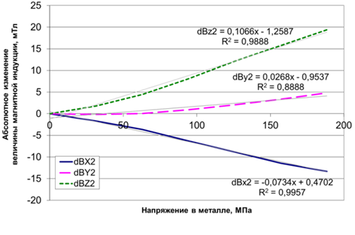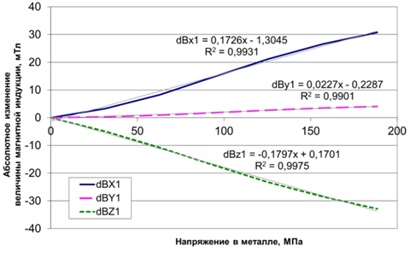
Fig. 10: Relation of the magnetic characteristics with values of mechanical stresses (demonstration of Villari effect)

The results of 12 years research and a database of field work were used in the development of national standards governing the terms and definitions, as well as general provisions of the magnetic tomography method. Full-scale programs on the verification were conducted in the USA, UK, as well as ASEAN region [G. Janega, V. Grigil, I. Kolesnikov. NYSEARCH’S VALIDATION PROGRAM OF TRANSKOR’S MAGNETIC TOMOGRAPHY METHOD OF PIPE INSPECTION, NYSEARCH/Northeast Gas Association; Pipeline & Gas Journal 2011, June, Vol. 238 No. 6, p. 22-23; Peter Martin. Magnetic Tomography Method (MTM) Pipeline Inspection System: Evaluation & Validation, Transmission Annual Report Gas Transmission 2011/2012 (Gas Transmission R&D Programme Detailed Reports National Grid (GB). Innovation Funding Incentive, p. 332-336].

For the purpose of validating the quality of MTM inspection, a special “Verification Procedure” was developed, it is included as a recommendation offer into drafts national standards (GOST) “Technical diagnostics using magnetic tomography method” (posted for the discussion on the ROSSTANDART portal).
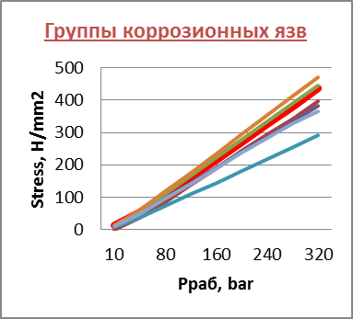
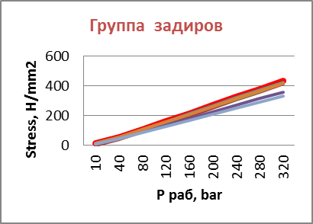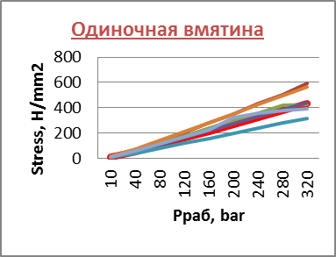
Fig. 11: Correlation of serviceability parameters of defective sections according to MTM data and by conventional methods
The main provisions of the procedure are set out in the publication [Editorial article "New technologies summary": Methodology of “Transkor-K” allows to evaluate the effectiveness of pipelines inspection, Oil and Gas Eurasia, 2011, №7-8 July-August, p. 14]. A Table for the results on the field pipeline (Indonesia) is given as an illustration of the results of two of the performed verifications.

LIST OF FIGURES

